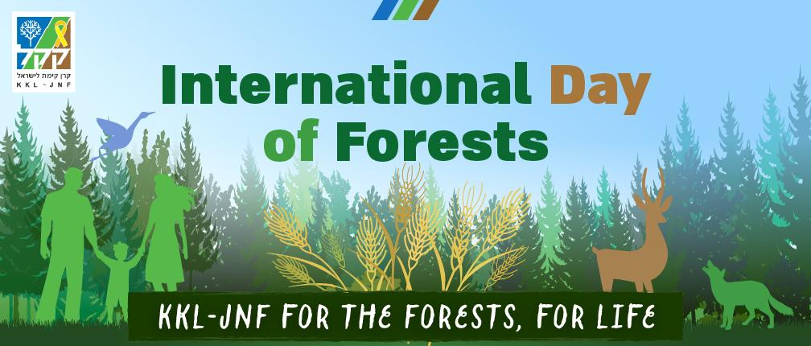

**KKL-JNF Forestry Figures**

|  |  |
| --- | --- |
| **Notable Forests**  Israel's first planted forest was the Herzl Forest (today Hulda Forest), in which the first ~18 olive trees were planted in 1907.  The country's largest forest, the Yatir Forest, extends over ~3,800 hectares (9,500 acres). | **Growth Over a Century**  The State of Israel is one of the few countries in the world that has more trees today than it did a century ago.  In **1901**, when KKL-JNF was founded, Israel had barely 1,400 hectares (3,500 acres) of forest.  In **1942**, the country had 3,500 hectares (8,750 acres) of planted forests.  In the early **1970s**, there were ~60,000 hectares (150,000 acres) of planted forests.  As of **2019**, KKL-JNF had planted more than 100,000 hectares (247,105 acres) of forests. |

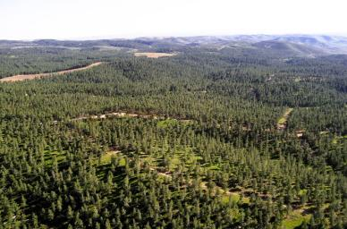

Yatir Forest, Albatross - KKL-JNF Photo Archive

**Tree Types and Forest Distribution**

.

**KKL-JNF Nurseries**

KKL-JNF has 3 tree nurseries, in which ~1,000,000 saplings are grown each year,

The rest of the trees are distributed to regional and local authorities, IDF bases, and educational institutions.

תמונה שמכילה שמיים, בחוץ, צמח, עץ

תוכן שנוצר על-ידי בינה מלאכותית עשוי להיות שגוי.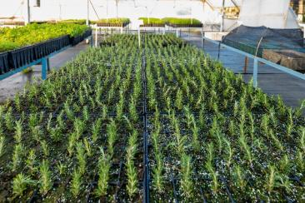

Bonnie Sheinman - KKL-JNF Photo Archive

**KKL-JNF Forests Contribution to Environment and Climate Crisis**

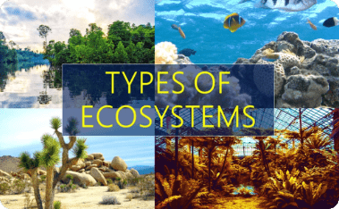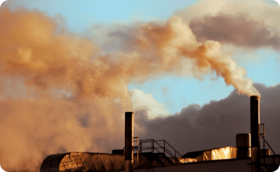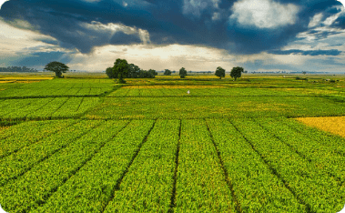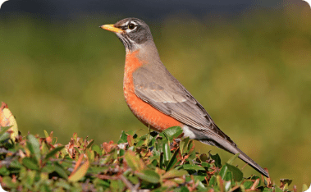

**Forest maintenance and conservation**

**Conserving the Unique Natural Values of Forests**

KKL-JNF forest management ensures that a wide variety of unique natural values can be found, including a spectacular array of colorful flowers such as anemones, irises, crocuses, orchids and more carpeting forest floors; and important bird nesting sites for diurnal and nocturnal raptors, burrow-digging bee-eaters, and rollers (Coraciidae).

**Post Wildfire Rehabilitation**

The rehabilitation of forests damaged by fire is based on natural renewal, to the extent possible, in accordance with forest management theory and policy. In the first phase, burnt trees that pose safety hazards are extracted. Forest treatment is planned based on a survey that monitors natural regeneration dynamics. After one or two years, additional intervention is assessed as needed..

**Forest Renewal**

Over the past decade, KKL-JNF has been revitalizing its older forests using advanced techniques based on modern forest management principles. These efforts have significantly improved the survival and growth of newly planted saplings in challenging environments. At the end of a forest's growth cycle, renewal focuses on promoting the natural regeneration of local species, complemented by planting native and coniferous trees suited to each habitat.

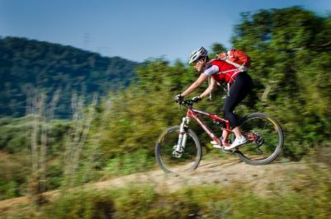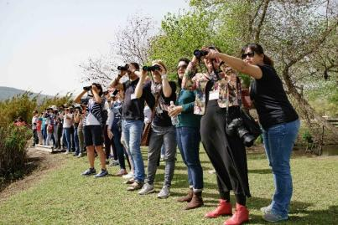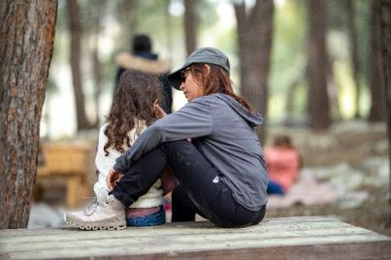**Leisure and Recreation**

**Information is based on the KKL-JNF Spokesperson's Office and the Forestry Dep.**