**Memorial Day 5785 / 2025**

**Cpt. Oshri Moshe Butzhak Z”L, 22 years old**

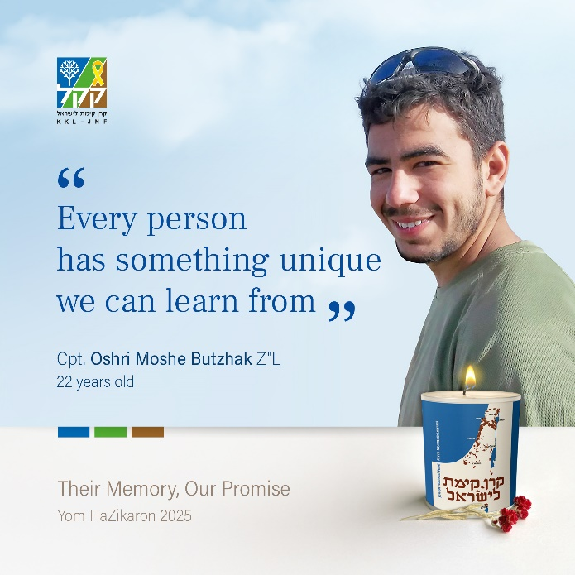  
Design by Orit Yeshayahu

***"Every person has something unique we can learn from."***

The path to command wasn’t easy for Oshri, but he never gave up. Protecting the people of Israel was his mission- one he lived and breathed, reading everything he could about IDF heroism and sacrifice.   
  
As a platoon commander in the Nahal Reconnaissance Unit, Oshri served in northern Gaza, clearing buildings of terrorists and explosives. Even there, amidst the raging fire of war, he always made time for Torah study, earning him the moniker “commander in King David’s army” from the brigade Rabbi.

On December 23, he was ordered to take over a building - but to wait until they could enter as a platoon. Suspecting that it was booby-trapped, Oshri opted to enter it alone. Yosef Kolozny, his advance guard and machine gunner, was meant to go in first. But Oshri, as commander, insisted on taking the risk upon himself.

He entered first, with Yosef behind him, providing cover. A Hamas gunman opened fire- Oshri was hit in the neck and chest, and Yosef was wounded in the leg. The soldiers later found a live explosive charge inside, intended to bring down the entire building. But Oshri, before he was killed, had managed to shoot the terrorist before he could trigger it - saving the lives of all 13 of his soldiers, whom he called his “children.”

Oshri, born and raised in Haifa, is survived by his parents Eyal (a KKL-JNF employee) and Reut, and his siblings Harel, Talia, Nevo, Haggai, and Tze’ela. Just a month earlier, he had gotten engaged to his beloved Ravid.

Even in death, Oshri chose to give: he had registered as an organ donor, and his corneas were successfully transplanted, offering the gift of sight to others.