**Emergency Aid to 9 Regional Councils in Southern Israel**

**Stand Strong, Southern Israel**

**KKL-JNF has streamed emergency aid to 9 regional councils in southern Israel under attack.**

**Your support directly contributes to the security and well-being of the Israeli residents living in these communities.**

Since the early hours of Saturday, October 7th, Israel’s residents have been facing vicious and violent attacks by terrorists that has left over 1,400 Israelis murdered, thousands injured, and dozens abducted by the terrorists.

War in northern Israel is looming.

In these challenging times, as Israel faces war and a relentless wave of attacks aimed at undermining its security and even its existence, Keren Kayemeth LeIsrael – Jewish National Fund (KKL-JNF) has decided to provide an emergency package to support nine local authorities and cities in southern Israel in the amount of one million NIS per authority, responding to the immediate needs following the massive attack they experienced.

The emergency basket includes bomb shelters to be deployed in the communities, generators, equipment for the formation of a local emergency team, and computers.

The people of southern Israel are facing a crisis, and they need our support now more than ever. Nine local councils in the region are under attack, and the situation is dire. The time to act is now, and we need your help to provide essential emergency aid to the communities affected.

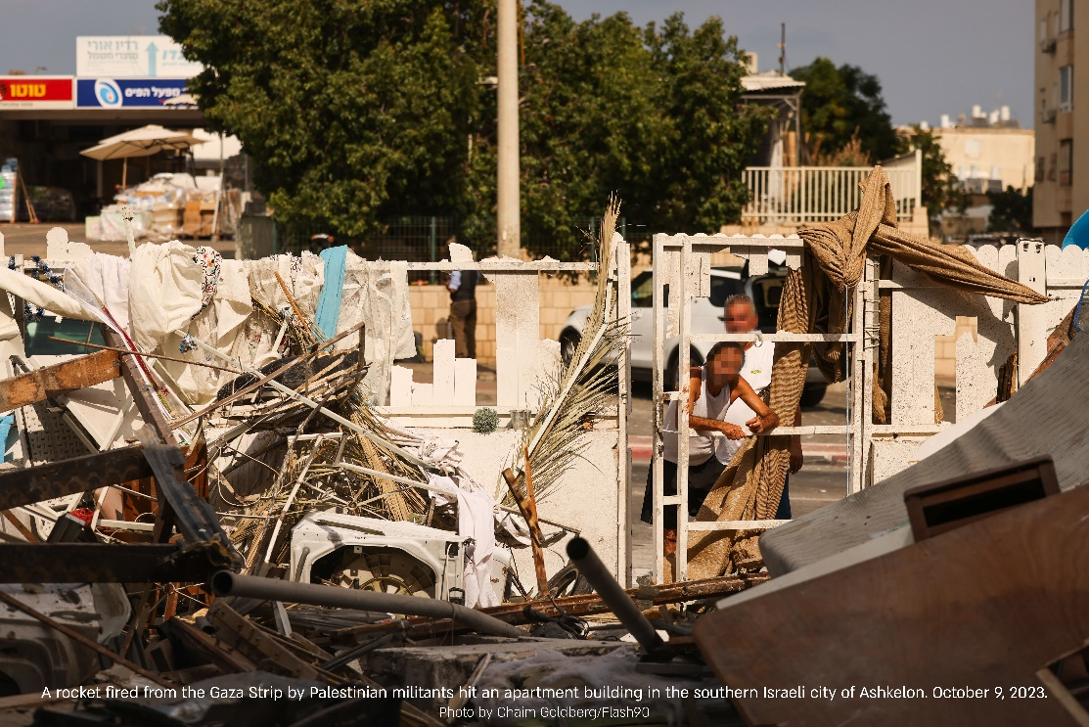

Your financial support will go directly towards providing aid to the local councils in Southern Israel.

**The strength of a community lies in its ability to come together in times of need. Let's show the people of southern Israel that they are not alone in this challenging moment.**

**Your support can bring hope and relief to those who need it the most and will directly contribute to the security and well-being of the Israeli residents living in these communities.**

**KKL-JNF invites you to join us in our emergency aid drive for the nine local councils in southern Israel under attack. Together, we can stand strong and make a positive impact on the lives of those who are suffering.**

**Project number: 20643**

**Project cost: NIS 9,000,000**