**Save Lives in Israel's South**

**Join KKL-JNF in Purchasing 10 Ambulances**

**KKL-JNF has launched an emergency drive to purchase 10 ambulances for the communities in Israel’s south. Join us and help save the lives of Israel’s citizens.**

Since the early hours of Saturday, October 7th, Israel’s residents have been facing vicious and violent attacks by terrorists, a massive terror incident that has left over 1,4000 Israelis murdered, thousands injured, and dozens abducted by the terrorists.

In these challenging times, as Israel faces war and a relentless wave of attacks aimed at undermining its security and even its existence, Keren Kayemeth LeIsrael – Jewish National Fund (KKL-JNF) and Ha'aguda Lema'an Hachayal, the Association for the Wellbeing of Israel's Soldiers (AWIS), have purchased 10 ambulances for the embattled communities in southern Israel.

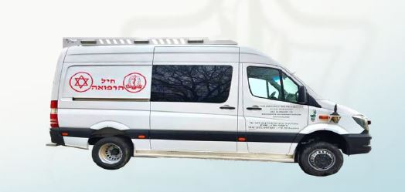

In times of crisis, every second counts. Right now, Israel's southern region is under attack, and the need for swift, efficient medical response is greater than ever before. Lives are hanging in the balance, and we need your support to make a difference.

Our mission is to equip Israel's southern region with the necessary resources to respond to emergencies effectively. With your support, we can provide the vital lifeline that our communities desperately need.

The ambulances are operated by the IDF’s emergency medical teams.

Ambulances are more than vehicles; they are the symbol of hope and healing during times of crisis. In Israel's south, these ambulances will serve as a beacon of hope, ensuring that medical professionals can reach victims swiftly, providing critical care when it matters most.

Your generous contribution can make a world of difference. By donating to this effort, you are literally saving lives.

**Let's come together in this time of crisis and make a tangible difference. Lives depend on it. Together, we can provide hope, healing, and safety to those who need it most.**

**KKL-JNF invites you to join us in our emergency ambulance campaign and help us purchase 10 life-saving ambulances to ensure rapid medical assistance to the residents of southern Israel.**

**Project number: 20644**

**Project cost: NIS 650,000 per ambulance**