PROJECT COST

NIS 100,000-200,000 PER COMMUNITY

PROJECT NUMBER

20645

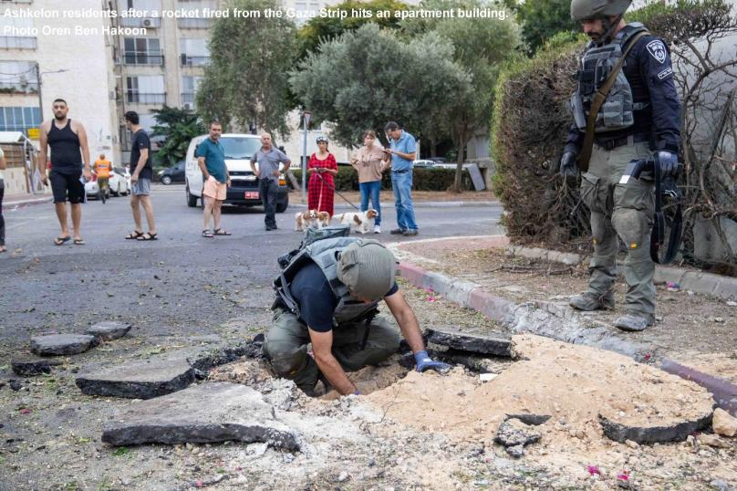

**KKL-JNF has equipped emergency rapid response teams in 48 communities in the Gaza Strip vicinity. Help us protect those who are on the front lines and are the first to protect us.**

PROJECT COST

NIS 100,000-200,000 PER COMMUNITY

PROJECT NUMBER

20645

Since the early hours of Saturday, October 7th, Israel’s residents have been facing vicious and violent attacks by terrorists that has left over 1,400 Israelis murdered, thousands injured, and dozens abducted by the terrorists.

In these challenging times, as Israel faces war and a relentless wave of attacks aimed at undermining its security and even its existence, Keren Kayemeth LeIsrael – Jewish National Fund (KKL-JNF) has funded the purchasing protective gear and equipment for members of the civilian defense team in 48 communities in the vicinity of the Gaza Strip.

The heroes who fended off the terrorists during the initial onslaught and stood on the front lines were members of the communal rapid response teams, civilians organized in local defense units who faced the terrorists with bravery while protecting their families and community.

KKL-JNF has allocated a sum of NIS 200,000 per community to equip the emergency teams close to the border with the Gaza Strip.

We must ensure that those who are entrusted with the safety of the communities in Israel’s south are fully equipped and prepared to face any threat.

**KKL-JNF invites you to join us in empowering the emergency response teams with the best gear available.**

**We cannot wait until the next emergency strikes – equip our heroes for success and triumph. Together, we can make Southern Israel a safer place for all.**