**“Operation Recreation”**

**Deploying 120 Recreational Tables at IDF Bases**

**KKL-JNF has deployed 120 recreational tables at IDF bases across the country. Join us in treating those who give their lives to protect us.**

In the early hours of Saturday, October 7th, Hamas terrorists stormed Israel’s border with the Gaza Strip, killing some 1,400 Israelis, including about 300 IDF soldiers, and wounding thousands.

Since that dark moment, the brave IDF soldiers have been operating tirelessly to fend off the attacks, demonstrating unwavering dedication to safeguarding Israel. They have encountered numerous terrorists, putting their lives on the line countless times.

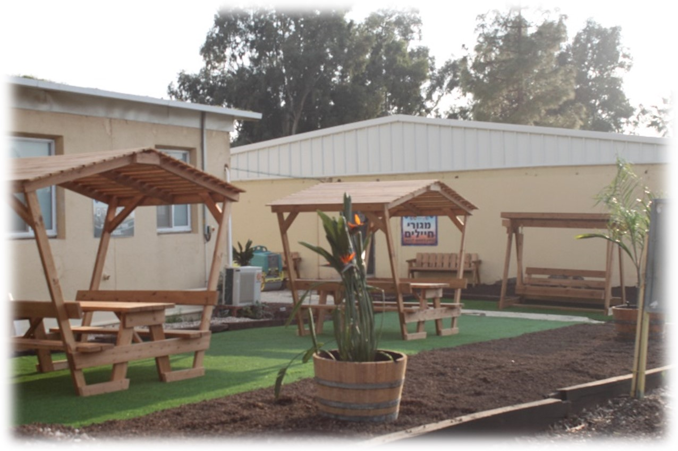

As we honor their sacrifice and commitment, we believe that maintaining their mental and physical well-being is paramount.

To enhance their morale and provide much-needed relaxation, Keren Kayemeth LeIsrael-Jewish National Fund (KKL-JNF), together with the Association for Israel’s Soldiers, introduced "Operation Recreation" – a campaign aimed at placing 120 recreational tables at IDF bases across Israel.

At the heart of "Operation Recreation" is the belief that even in the most challenging circumstances, our soldiers deserve moments of respite and recreation. We aim to create spaces within IDF bases that foster camaraderie, relaxation, and stress relief, ensuring our troops return to their duties with renewed strength and determination.

The shaded outside recreational tables offer soldiers an opportunity to unwind, bond with their comrades or families, and take a mental break from the stresses of combat.

Your financial support will go directly towards financing recreational tables at IDF bases.

"Operation Recreation" is a testament to KKL-JNF’s unwavering commitment to the well-being of IDF soldiers. Every donated recreational table and every moment of relaxation it brings will contribute to the physical and emotional strength of those who protect our nation.

**In these challenging times, the well-being of our soldiers is non-negotiable. "Operation Recreation" is a gesture of appreciation, support, and unity.**

**KKL-JNF invites you to join us in creating a more relaxed and resilient IDF, ensuring that our soldiers can face any challenge with renewed vigor.**

**Project number: 20657**

**Cost per table: NIS 4,500**