**Photo by Jamal Awad-Flash90**

**Stand with Israel –**

**Unite Against Terrorism**

**Join KKL-JNF**

**Israel’s south is under unprecedented vicious and violent terror attacks. Your help is needed to support the embattled Israeli families. These innocent families have endured unimaginable suffering and loss, they were forced to flee their homes, leaving behind everything they know and love. We must help them.**

Since the early hours of Saturday, October 7th, Israel’s residents have been facing vicious and violent attacks by the Hamas terrorist organization, a massive terror incident that has left over 1,400 of Israelis murdered, thousands injured, and dozens abducted by the terror organization.

**Join us to support Israel’s citizens at their worst moments!**

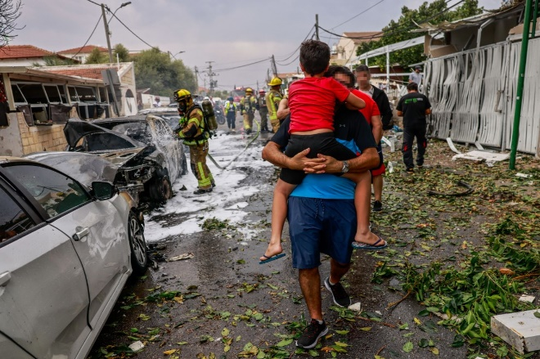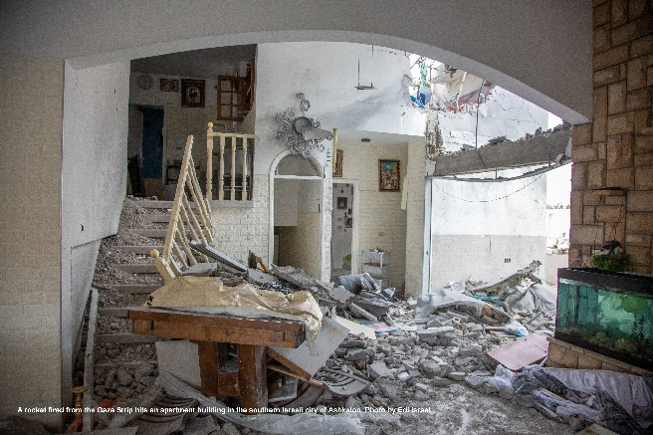

Photo by Chaim Goldberg-Flash90

Photo by Edi Israel, KKL-JNF Photo Archive

In these challenging times, as Israel faces a relentless wave of terrorism aimed at undermining its security and even its existence, Keren Kayemeth LeIsrael – Jewish National Fund (KKL-JNF) invites you to join hands with us in a united effort to support Israel and its citizens, a nation that has consistently stood as a beacon of resilience in a turbulent region, the only Jewish state in the world.

**KKL-JNF aims to aid those affected by the attacks, supporting initiatives that provide medical aid, food, and shelter to the victims.**

**Your generous contributions will go towards providing much-needed humanitarian aid and supporting rehabilitation initiatives.**

**Project cost: NIS 10-10,000,000**

***KKL-JNF invites you to join us and support this journey toward resilience and solace for the residents of southern Israel.***

קרן קימת לישראל

Keren Kayemeth LeIsrael-Jewish National Fund

Resource Development and External Affairs Division

Marketing Department

Jerusalem 2023