
Northern Families Recharge and Regain Strength Away from the Line of Fire
KKL-JNF is currently hosting around 8,000 residents from northern border communities in hotels across the country. The children are enjoying three days of fun and respite activities, while parents are able to rest, even if just a little, in a calmer environment.
“After all the missiles we’ve endured recently, it’s good that the children can have a few calmer days,” said Kfir Dadon, who is staying at a hotel in Jerusalem with his two children.
“It’s so nice to have the freedom to go outside a bit,” enthused Ellie Lagrisi, as her older brother Liv nodded in agreement.
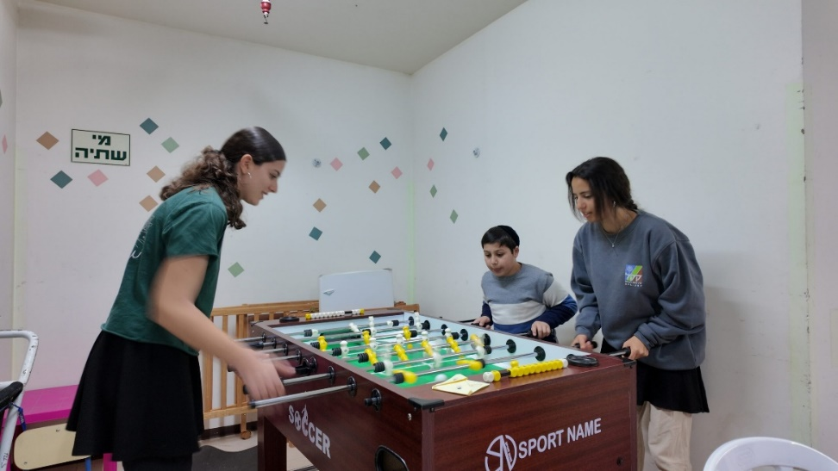
“KKL-JNF is measured precisely in moments like these, by its ability to extend a helping hand quickly and give people the strength to keep going,” said KKL-JNF Chairman Eyal Ostrinsky in a message to the visiting families.
“We initiated this program to offer a few days of relief and renewal,” added Nissim Magnagi, Director of KKL-JNF’s Community Department.
Emily Atzmon, who arrived at the hotel with her seven children, said: “We’re going through a very difficult time with constant sirens. Taking cover with seven children is not simple at all, so it’s good that we have the chance to rest and recover. The children need this so much, like air to breathe.”
“It’s good to be able to breathe a little and not feel under constant pressure,” said Tamar Cohen. Her father, Uriel, added: “Thank you to KKL-JNF for giving our family, and really our entire community of Shlomi, this chance to recharge.”
The children took part in games, workshops, performances, and a wide range of activities led by guest artists and KKL-JNF national service volunteers.
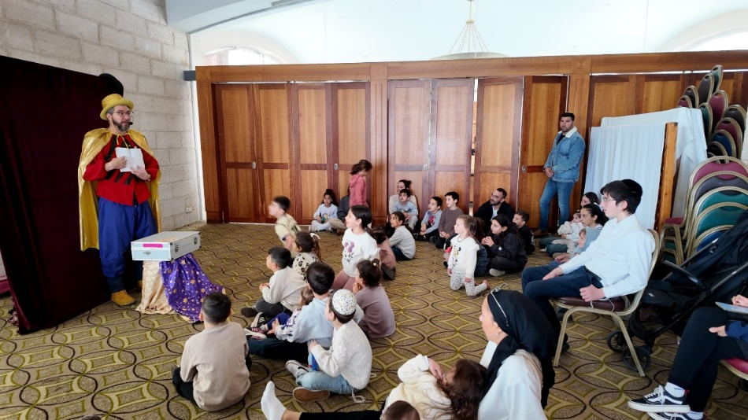
Zion Renert, a volunteer from Yokneam, led a creative workshop for children at a hotel in Jerusalem. “There’s a real sense of purpose in helping families from the northern border and giving their children a moment of calm,” she said.
When a siren sounded at the hotel, none of the guests were overly alarmed. They are, after all, used to far more back home than a single daily alert. Everyone efficiently made their way to the protected area and, once cleared by the Home Front Command, quickly returned to enjoying their break.
“These days of respite are really helping us to unwind from the situation in the north and the country in general,” said Gilad Mualmi from Moshav Ein Ya’akov.
“It’s great to go on a break instead of constantly running to shelters, so a big thank you to KKL-JNF,” said Riki Saada, a 37-year-old woman with special needs.
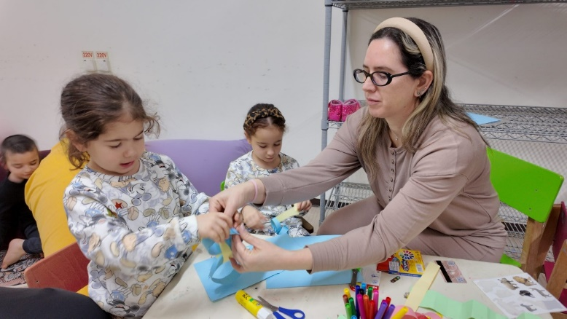
Karin Dadon also expressed her gratitude: “Thank you so much to the KKL-JNF team for this chance to recharge and for the wonderful activities for the children.”
After three days of rest and renewal, it will be time to return home with renewed strength. And despite the ongoing attacks and relentless sirens, one thing is clear, no one is willing to give up on their home.

