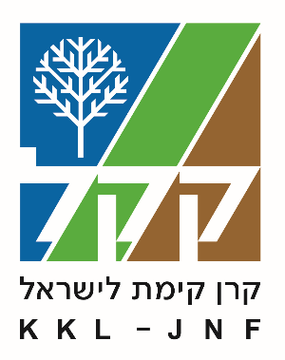

KKL-JNF 2025 Tu BiShvat "Planting Life" Campaign

DESKS AND KKL REPRESENTATIVES: HERE'S YOUR PITCH!
Your guide to promoting the 2025 Tu BiShvat Campaign effectively and succinctly.

Second Tu BiShvat since the war
- 1,800 Israelis killed
- 22,700 injured
- 251 abducted
- 80 communities displaced

Nature is suffering too
- Fires caused by missile attacks
- Blackened forests, barren land, desolation
- 23,000 hectares burned, including 2,900 hectares of KKL-JNF forests

Forests are lifelines for communities
- Forests near Be’eri and Birya provide shade, recreation, and emotional solace.
- They are essential for the environment, economy, and resilience of the people who live nearby.

Focus on "Planting Life"
- Planting, rebuilding, and restoring
- Birya Forest (North)
- Be'eri Forest (South)

These forests are more than trees
- North: Fortress, ancient synagogues, tombs of sages near Tzfat, biking trails
- South: Cycling, Darom Adom Festival

KKL-JNF's priorities
- Reviving ecosystems through natural regeneration
- Careful intervention and planting resilient species
- Supporting community rehabilitation

With your help, we will make tomorrow bloom!

קרן קימת לישראל
Keren Kayemeth LeIsrael-Jewish National Fund
Resource Development and External Affairs Division
Marketing Department

