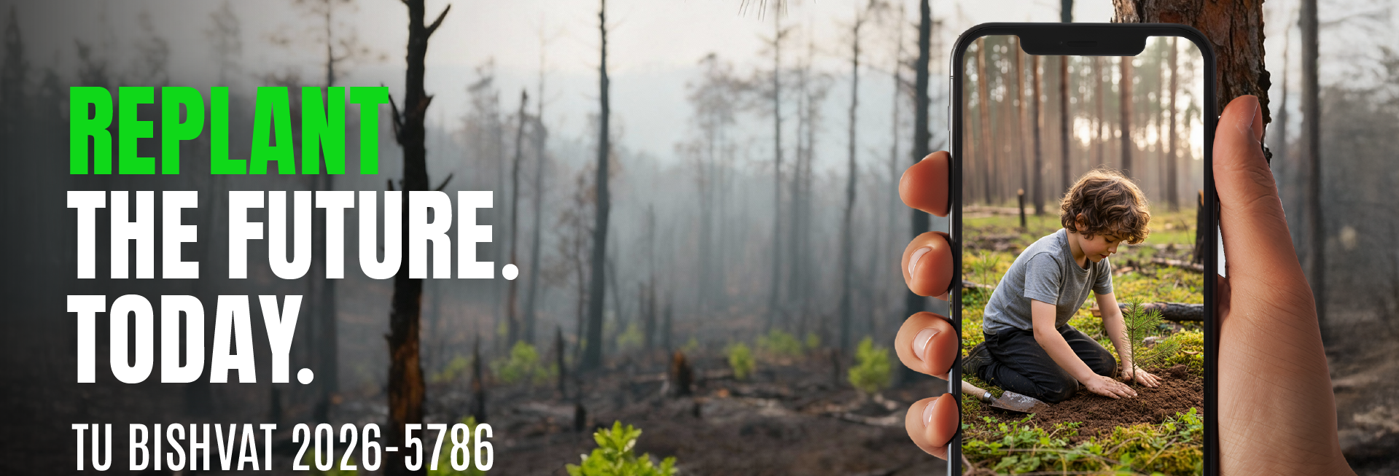

Your guide to promoting the Tu BiShvat 2026 Campaign effectively and succinctly.

KKL-JNF REPRESENTATIVES:
HERE'S YOUR PITCH!

Third Tu BiShvat since the war
- Nearly 2,000 Israelis killed
- More than 30,000 injured
- 80 communities displaced
- 1 Israeli still in captivity
- 7 fronts war, tenuous ceasefires both in the North & South

Nature is suffering from war
- Blackened forests, barren land, desolation
- 23,000 hectares of open land burned, including 2,900 hectares of KKL-JNF forests
- Amnun forest: nearly two-thirds of new planted areas burned in the war due to rocket fire. Significant damage to irrigation system as well.
- Re’im forest: Fires caused by previous arson balloon attacks, drought and soil erosion, and war related activity.

Forests are lifelines for communities
- Forests near Re'im and Amnun provide shade, recreation, and emotional solace.
- Essential for the environment, economy, and resilience of the people who live nearby.

Focus on "Replanting"
- Planting, rebuilding, and restoring
- Amnun Forest (North)
- Re'im Forest (South)

These forests are more than trees
- North: Pilgrim’s Trail, wildlife, recreational spaces, shore of the Galilee
- South: includes sites of Nova Festival, Be’eri Cycling Trail, Hiking, Darom Adom Festival, annual Kibbutz Be’eri Tu BiShvat tree planting ceremony

KKL-JNF's priorities
- North: Preservation and restoration of natural forests. Maintaining archaeological activities, trail development, and service roads.
- South: Restoration planting up to the fence line. Community rehabilitation that leads to active, safe, and thriving tourism. (Delegations can visit the planting sites during planting and participate in planting activities.)
Stand with us this Tu Bishvat. Help replant the forests that will carry Israel toward a greener, safer, more united tomorrow.

